C# Development Exercise

Write a simple evaluator which will parse and evaluate expressions like the
following:

(5 + 5) * (3 + 2) - 1

It only needs to support the operators * + - () and unary minus.

The submission should be in C# .

The submission should be presented with a user interface.

We will be considering:

1) Is it readable and understandable?
2) Could the implementation be extended?
3) What were the design decisions? What are the trade-offs?

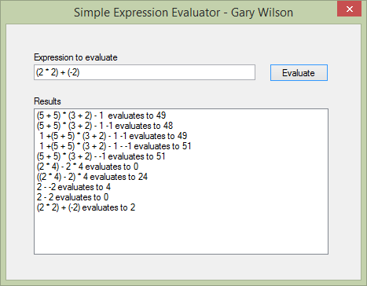

Please see software code in project zip file.

